Introduction
Mumbai is one of the major cities in India spread across an area of 4355 sqkm and a population of 20 Million. Mumbai is the financial capital of India and is one of the most densely populated cities in the world. It lies on the west coast of India and attracts heavy tourism from all over the globe every year. It is one of the major hubs of the world and has people from all across the world live here. The multi-cultural nature of the city of Mumbai has brought along with it numerous cuisines from all across the world.
We are trying to analyse varied locations in Mumbai with the objective to determine the possibility of a suitable location of a Restaurant. The task to do so becomes very challenging because of the wide area of Mumbai, multi-cultural Populace and varied tastes. This project will bring value to Entrepreneurs who are looking to start up a restaurant in Mumbai. We intend to carefully analyse the freely and provide recommendation on the location of the restaurant along with type.

Data Section
We intend to use the following data :
- Neighbourhood data of Mumbai – We have used Wikipedia for this and used the following link:
https://en.wikipedia.org/wiki/List_of_neighbourhoods_in_Mumbai
- Geographical coordinates of Mumbai and all neighbourhoods in Mumbai- We will use Geopy library in python to obtain each neighbourhood latitude and longitude for cross verification.
- Venue data for neighbourhoods in Mumbai- We used Four Square data API to get Venue data for all neighbourhood as this will give us insight into all neighbourhood popular places.
We will consolidate all the data above to get a data frame which has neighbourhood, locality, Latitude ,Longitude along with top 10 most popular places for each venue. Post this we will run a cluster analysis to segregate all the data into 5 cluster and this in turn will provide us with a cluster which is best suited for opening a restaurant.

Neighbourhood’s Data(Wikipedia)
We scrapped the data from Wikipedia. The data was read into a data frame using read_html() method and the data was further cleaned for usage. The top 5 rows which includes location, neighbourhood, latitude and longitude
The data of the neighbourhoods in Mumbai was scraped from https://en.wikipedia.org/wiki/List_of_neighbourhoods_in_Mumbai. The data is read into a pandas data frame using the read_html() method. The main reason for doing so is that the Wikipedia page provides a comprehensive and detailed table of the data which can easily be scraped using the read_html() method of pandas. The top 5 rows of the dataframe are shown in Figure1.

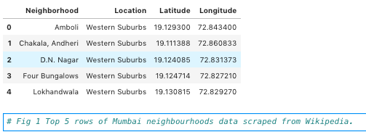

Geographical Coordinates(GeoPy)
The geographical coordinates for Mumbai has been obtained from the GeoPy library in python. This data is relevant for plotting the map of Mumbai using the Folium library in python. The code for getting the geographical coordinates of Mumbai is shown in Figure 2.
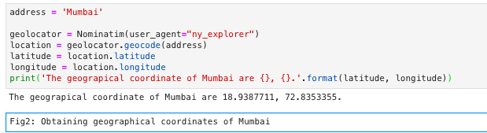
The geocoder library in python has been used to obtain latitude and longitude data for various neighbourhoods in Mumbai. The coordinates of all neighbourhoods in Mumbai are used to check the accuracy of coordinates given on Wikipedia and replace them in our data frame if the absolute difference is more than 0.001. These refined coordinates are then further used for plotting neighbourhoods using the Folium library in python. Figure 3 shows the coordinates of neighbourhoods in Mumbai obtained from Wikipedia as ‘Latitude’ and ‘Longitude’ and those obtained from geocoder as ‘Latitude1’ and ‘Longitude1’. Furthermore, it also shows the absolute difference between the two latitude columns and the two longitude columns as ‘Latdiff’ and ‘Longdiff’, respectively. Once again only the top 5 rows are shown.
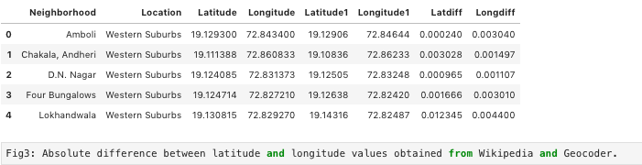
Figure 4 shows the top 5 rows of the final Mumbai neighbourhoods dataframe after replacing the latitude and longitude values as mentioned before and dropping unnecessary columns.
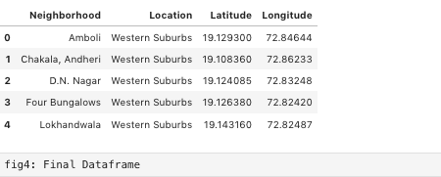

Venue Data(Foursquare API)
The venue data has been extracted using the Foursquare API. This data contains venue recommendations for all neighbourhoods in Mumbai and is used to study the popular venues of different neighbourhoods as well as build the unsupervised learning model to cluster neighbourhoods. The venue recommendations of all neighbourhoods were obtained with a limit of 200, that is, maximum of 200 venue recommendations per neighbourhood and a radius of 1 km around the neighbourhood’s geographical coordinates. Figure 5 shows the top 5 rows depicting the results obtained after cleaning the data from Foursquare API.
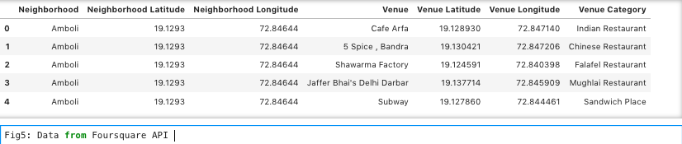

Methodology
This section provides details for the methodology used in the project.

Data Visualization
In order to understand the data obtained for Mumbai neighbourhoods, basic visualization was carried out. Figure 6 shows a bar plot depicting the number of neighbourhoods in each location in Mumbai.
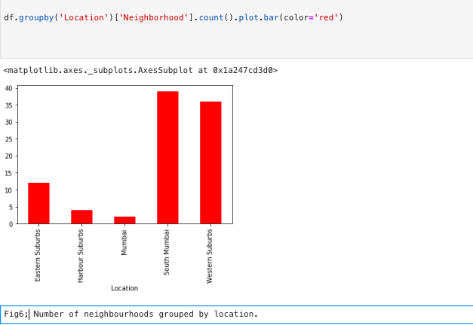
It is evident from Figure 6 that South Mumbai and Western Suburbs have the most number of neighbourhoods. Notice how we see one of the locations as Mumbai itself? This is because the neighbourhoods contained in this location are located at the outskirts of the city and thus have been termed as just Mumbai. Using folium, a map was plotted to show how the different neighbourhoods are spread all across Mumbai. 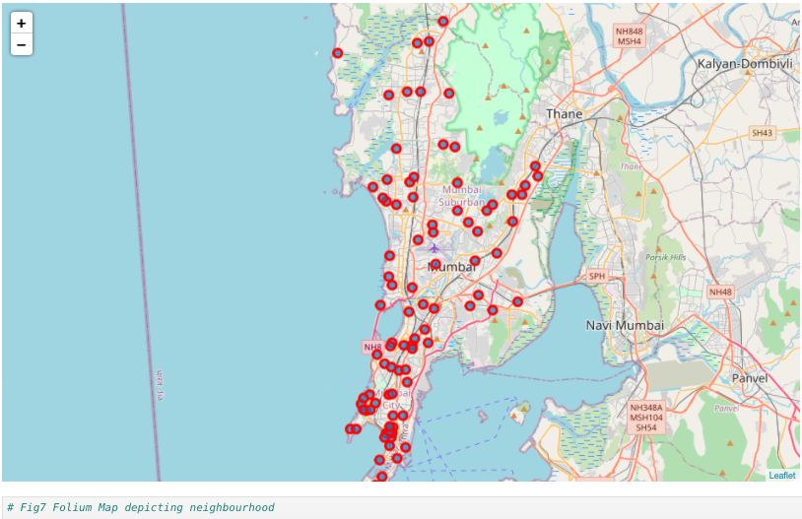

Feature Extraction
Feature extraction was carried out to obtain features from the Foursquare API data (as shown in Figure 5) which was used for building the unsupervised learning model. In order to achieve this, the “Venue Category” column had to be converted to some form of numeric value to be used for building the model. This was achieved by the One-hot Encoding method which takes all the unique categories and creates a column for each category. Then, if a neighbourhood venue belongs to that category, it would get a value of 1 for that row in that specific category column and if a neighbourhood venue does not belong to the particular category, the value would be 0. This process was repeated for all venues in all neighbourhoods and the result was a sparse matrix containing the neighbourhood name and all unique category columns with either 1 or 0 based on whether the neighbourhood venue belonged to that category or not. This dataframe was then grouped by the neighbourhood name and the average value was taken for all categories. The result is shown in Figure 8 which shows only the top 10 rows.
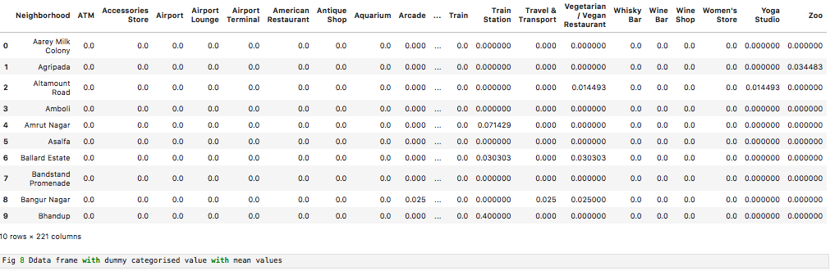
Notice that most of the values are 0 since there were a large number of unique categories and not all neighbourhoods had venues belonging to each category. This data was used for the unsupervised learning model with the neighbourhood name dropped. The unsupervised learning model is explained in the next section.
A dataframe was also created which contained the top 10 most common venues of all neighbourhoods. Though this is not a part of Feature Extraction, it is important to provide a glimpse into what this dataframe looks like as it will be used later to combine the results from the unsupervised learning model. The top 10 rows of this dataframe are shown in Figure 9.
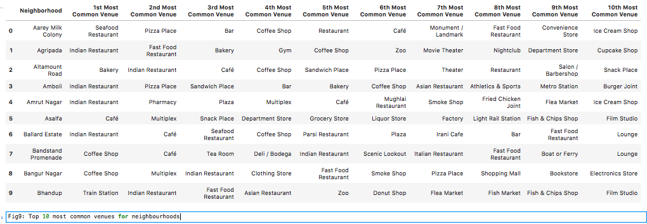

Unsupervised Learning
K-means unsupervised learning technique was used to cluster the neighbourhoods based on the category of venues near the neighbourhoods. One important aspect of the k-means model is to determine the number of clusters to use in model development.

Results
The clustering model then clusters the neighbourhoods in Mumbai and provides a label for each neighbourhood which is representative of the cluster it belongs to. The cluster labels were then added to the dataframe in Figure 9 along with the Location, Latitude, and Longitude columns to provide a complete summary of the clustering. The top 10 rows are shown in Fig 10
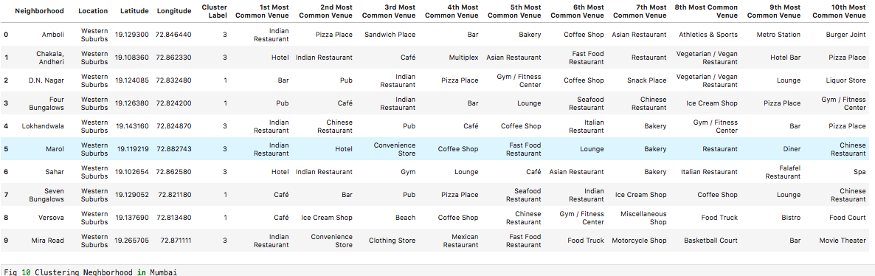
Furthermore, neighbourhoods in each individual cluster can be extracted using cluster labels and thus the details of specific clusters can be seen. This is done below for all clusters with rows for clusters that contain a high number of neighbourhoods.
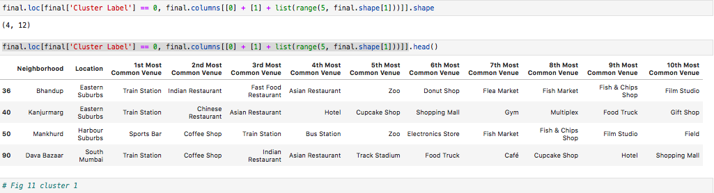
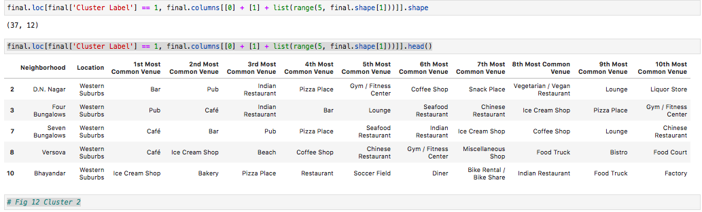
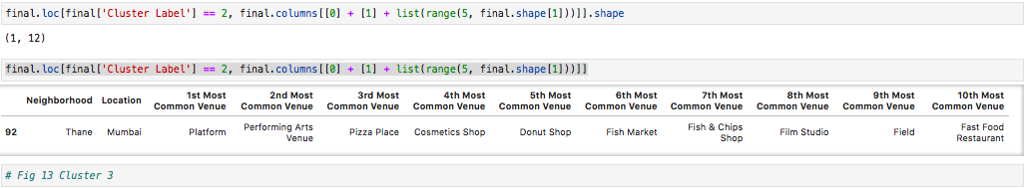
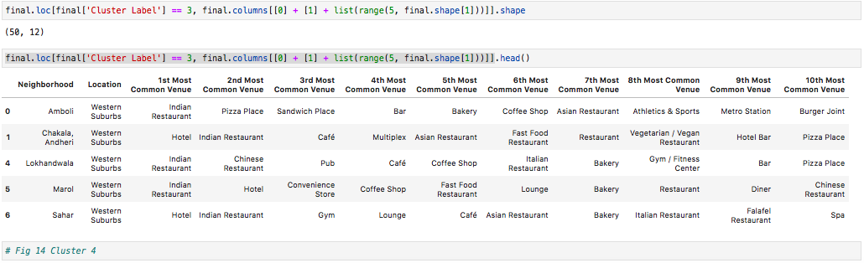
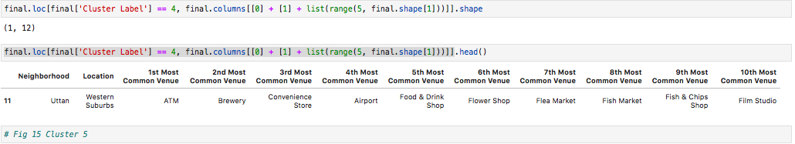
Based on the clusters shown above, the neighbourhoods can once again be plotted on a map of Mumbai, however, this time with different colour markers to distinguish between different clusters. This is shown in Figure 16.
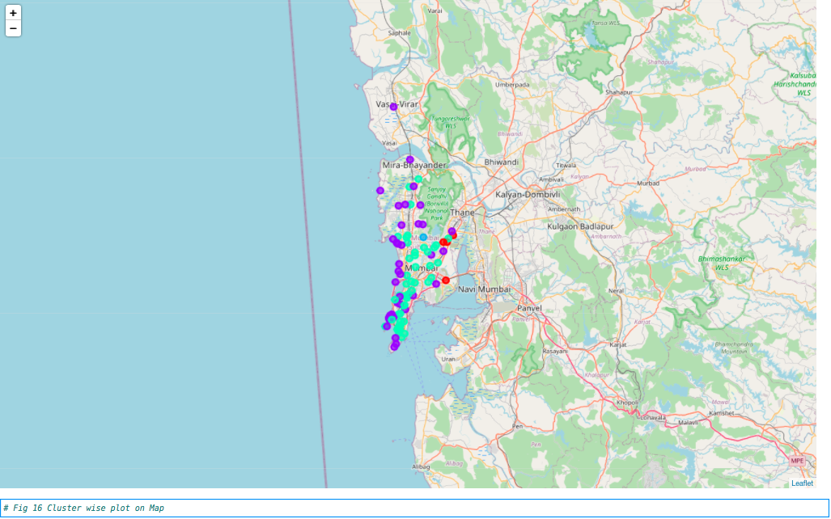

Discussion
By analysing the five clusters obtained we can see that some of the clusters are more suited for restaurants and hotels, whereas, other clusters are less suited. Neighbourhoods in clusters 1, 3, and 5 contain a small percentage of neighbourhood with very few restaurants, hotels, cafe and pubs in their top 10 common venues. These clusters contain a higher degree of other venues like train station, bus station, fish market, gym, performing arts venue and smoke shop, to name a few. Thus, they are not well suited for opening a new restaurant. On the other hand, neighbourhoods in clusters 2 and 4 contain a much higher degree of restaurants, hotels, multiplex, cafes, bars and other food joints. Thus, the neighbourhoods in these clusters would be well suited for opening a new restaurant. When we look at cluster 2 we see lot of bars, pubs, restaurants, tea rooms, bakery, cafe, steakhouse and Italian and seafood restaurants in the top 10 most popular venues. This kind of indicates that people visiting here are young and prefer to try different things . When we look at cluster 4 we notice that generally top most popular venue over here is Indian restaurants and then the rests are populated by Cafes ,Fast Food joints etc. Considering the fact that we are looking for a restaurant based on popularity an Indian restaurant, we recommend cluster 4.Cluster 4 is plotted on a map as shown below in Figure 17.
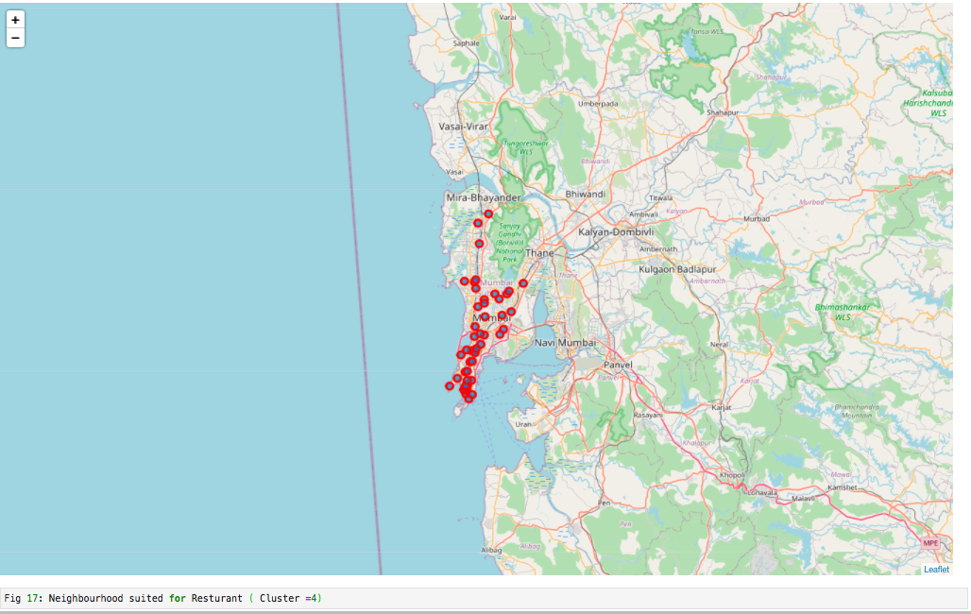

Conclusion
Our recommendation is to go for considering the popularity of Indian restaurants ,however before deciding on location criteria’s like location availability, property prices, rules & regulation, permits, licenses, logistics must also be taken into account.

